LAB 3 OUTPUTS

Q1. Write a C# program using async and wait for long process.

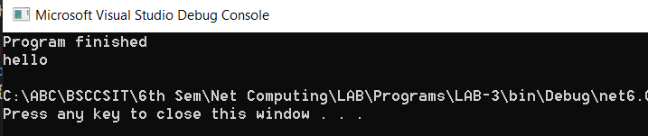

Q2. Write a program to find the upper case letter in string using LINQ

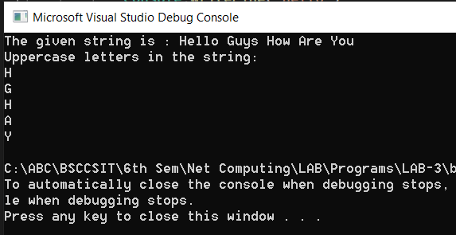

Q3. Write a program in C# Sharp to find the number of an array and the square of each number using LINQ

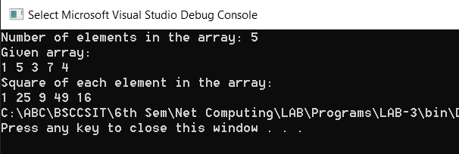

Q4. Write a program in C# Sharp to display the characters and frequency of character from the string given by the user.

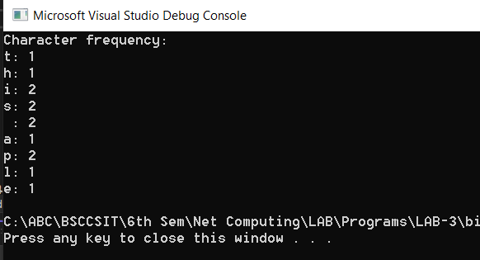

Q5. Write a program in C# Sharp to find the string which starts and ends with a specific character to find the string which starts and ends with a specific character.

The cities are :

'ROME','LONDON','NAIROBI','CALIFORNIA','ZURICH','NEWDELHI','AMSTERDAM','ABU DHABI','PARIS'

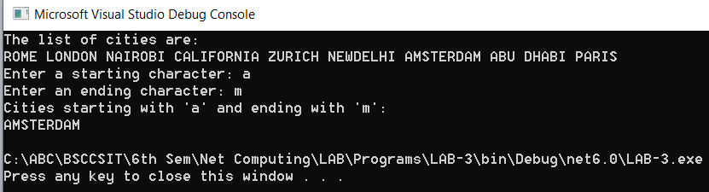

Q6. Write a program in C# Sharp for joining the two different objects data using LINQ

